**Carbon Credentials Developer Test**

**Background**

At Carbon Credentials we help our clients to reduce their energy consumption, in order to do this, we need to collect, visualise and analyse energy data.

Attached is one month of half hourly energy consumption for several hotels.

Half hourly data shows how much energy was consumed in the previous half hour. For example, a reading of 100 kilowatt hours at 12:30 shows that 100 kilowatt hours were consumed between 12:00 and 12:30.

Each hotel has either an electricity supply, a natural gas supply or both. Fuel consumption is measured through meters (same as the electricity or gas meters in your house), a meter holds information about the fuel, the unit of consumption (usually kilowatt hours) and location.

**Task**

The aim of this test is to demonstrate an ability to manipulate raw data files, create a suitable database structure, read and write data to a database, use the Django web framework and visualise data. Half hourly data is a large part of the data we analyse daily and Carbon Credentials, so this test is to assess how you can work with it. We are also often presented with new data sources and formats that we need to rapidly create data extraction pipelines, models and visualisations for.

Using Django and whichever sql database (e.g SQLite, PostgreSQL) and third-party libraries you feel are appropriate, create a web application which is capable of the following:

* Uploading the attached (or any) csv files via a web form and writing the data to a database via a Django model.
* Simple data exploration through Django views and html tables showing a list of buildings, then a list of meters for each building with hyperlinks etc.
* One simple visualisation of energy consumption using whatever graph or chart you feel is useful (using a third-party library is fine). One way of doing it could be to plot the half hourly data for each meter in a line chart, or perhaps sum the energy consumption per day across every hotel and draw a bar chart. Below are some examples of visualisations we use on our platform. You don’t need to recreate these charts, they are just to give you some ideas.

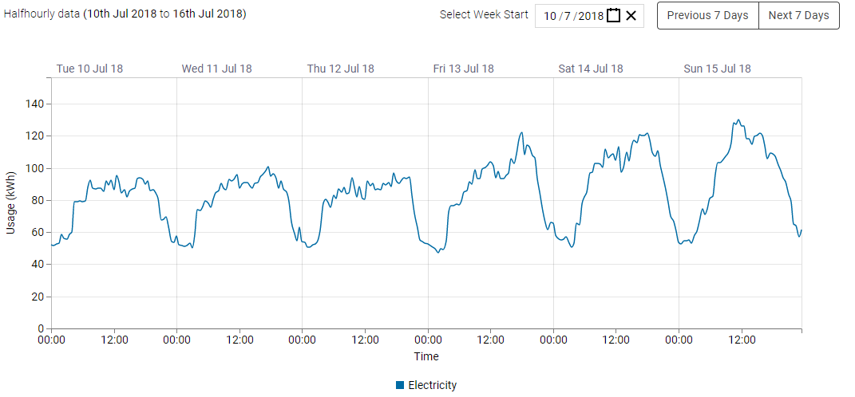

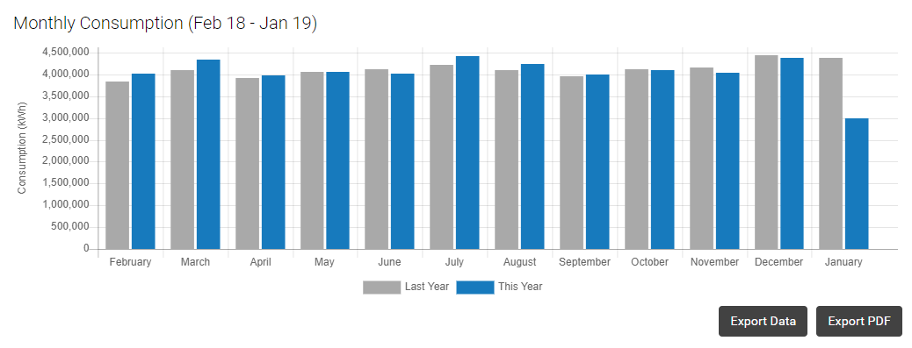

The structure, layout and content of the application is up to you, the challenge is to look at the raw data and create something that allows us to upload the data and gain some insight into it.

As part of this task you will need to create suitable Django models to store this data, including foreign keys.

The solution needs to be under git source control and, if possible, uploaded to a repository such as bitbucket or github.